|  |  |  |  |  |  |  |
| --- | --- | --- | --- | --- | --- | --- |
| |  |  |  |  | | --- | --- | --- | --- | |  | | **MINISTRY OF EDUCATION AND TRAINING** | | | **FPT UNIVERSITY** | | |
| Capstone Project Document |
| Online Medical Consultant System |
| |  |  |  |  |  |  |  |  |  |  |  | | --- | --- | --- | --- | --- | --- | --- | --- | --- | --- | --- | | |  |  | | --- | --- | | **Group 02** | | | **Group member** | Trần Nguyên Tiến Sứ - Team Leader - SE60781  Trần Cao Danh - Team Member - SE60705 | | **Supervisor** | Mr. Nguyễn Huy Hùng | | **Ext. Supervisor** | N/A | | **Capstone Project code** | OMCS | | |
| * Ho Chi Minh City, 07 / 2014 – |

# Table of Content

Table of Content 2

List of Figures 4

Report No.5: System Implementation & Test (SIT) 5

5.1. Introduction 5

5.1.1. System Overview 5

5.1.2. Test Approach 5

5.2. Database relationship diagram 6

5.3. Performance measures 6

5.4. Test Plan 6

5.4.1. Features to be tested 6

5.4.2. Features not to be tested 8

5.4.3. Testing Tools and Environment 8

5.5. Test cases 9

5.5.1. <User> Login 9

5.5.2. <User> Logout 11

5.5.3. <User> Register 11

5.5.4. <User> Homepage’s navigation 12

5.5.5. <User> 404 page 12

5.5.6. <User> Access Denied page 12

5.5.7. <User> Remember me 12

5.5.8. <User> Forget password 12

5.5.9. <Patient> Edit patient information 12

5.5.10. <Patient> Edit health record 12

5.5.11. <Patient> View medical profile 12

5.5.12. <Patient> Chatting 12

5.5.13. <Patient> Attach files 12

5.5.14. <Doctor> List patients 12

5.5.15. <Doctor> Add patient 12

5.5.16. <Doctor> Edit patient 12

5.5.17. <Doctor> View patient 12

5.5.18. <Doctor> List medical profiles 12

5.5.19. <Doctor> Edit medical profile 12

5.5.20. <Doctor> Doctor chatting 12

5.5.21. <Doctor> Request webcam 12

5.5.22. <Doctor> View medical profile structure 12

5.5.23. <Admin> Edit hospital information 13

5.5.24. <Admin> List patients 13

5.5.25. <Admin> Add patient 13

5.5.26. <Admin> Edit patient 13

5.5.27. <Admin> List specialty fields 13

5.5.28. <Admin> Edit specialty field 13

5.5.29. <Admin> Add specialty field 13

5.5.30. <Admin> List medical profile template 13

5.5.31. <Admin> Add new medical profile template 13

5.5.32. <Admin> Edit medical profile template 13

5.5.33. <Admin> List film types 13

5.5.34. <Admin> Add film type 13

5.5.35. <Admin> Edit film type 13

5.5.36. <Admin> List allergy type 13

5.5.37. <Admin> Add allergy type 13

5.5.38. <Admin> Edit allergy type 13

# List of Figures

Figure 1: MVC Architecture 6

Figure 2 Component Diagram 7

Figure 3: Class Diagram 8

Figure 4: Define new medical profile template 9

Figure 5 Doctor Update Medical Profile 9

Figure 6 Patient update Personal Health Record 10

Figure 7 Doctor view Medical Profile Record 10

Figure 8 Patient view Medical Profile Record 11

1. System Implementation & Test (SIT)
   1. Introduction
      1. System Overview

- The system is implemented using MVC architecture and comprises of three parts. The first one is used by the hospital admin to build medical profile templates, manage users. Second part is used by doctors to create medical profile for patients, update patient’s information. The last one is for patients to view their medical profiles, update information, get consulted.

* + 1. Test Approach

- Testing approach defines the scope and goals of testing phase. It describes the strategy for the test, what will be test and what will not, the method used for testing and how much resources are required to perform the test.

- Method: System Testing, Black-box Testing.

* 1. Database relationship diagram

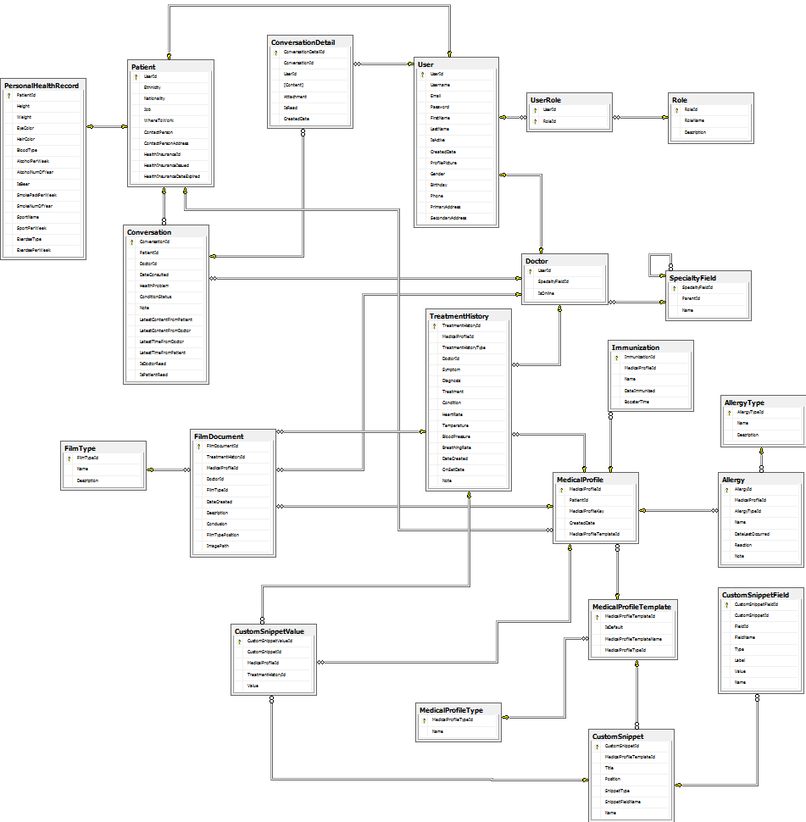

* 1. Performance measures
     1. Assumptions
        1. Software and Hardware
* CPU: Core i3 2.13Ghz
* Network connection: 72.0 Mbps
* Hard Drive: 320GB
* Memory: 4096MB RAM
* Version of Operation System: Windows 7 Professional 64-bit
* Version of Software:
  + Web Server: ISS Express 8.0.8418.0
  + Database: SQL Server 2008 R2
    - 1. Performance requirement

|  |  |
| --- | --- |
| Metric | Value |
| Average Page Load Time | < 4 sec |
| Max Page Load Time | < 60 sec |
| Minimum Throughput | Per scenario |
| Max Number of Registered Users | 2000k |
| Max Records in the Database | 4000k |
| Max Database Size | 2GB |

* 1. Test Plan
     1. Features to be tested
        1. <User> Login
        2. <User> Logout
        3. <User> Register
        4. <User> Homepage’s navigation
        5. <User> 404 page
        6. <User> Access Denied page
        7. <User> Remember me
        8. <User> Forget password
        9. <Patient> Edit patient information
        10. <Patient> Edit health record
        11. <Patient> View medical profile
        12. <Patient> Chatting
        13. <Patient> Attach files
        14. <Doctor> List patients
        15. <Doctor> Add patient
        16. <Doctor> Edit patient
        17. <Doctor> View patient
        18. <Doctor> List medical profiles
        19. <Doctor> Edit medical profile
        20. <Doctor> Doctor chatting
        21. <Doctor> Request webcam
        22. <Doctor> View medical profile structure
        23. <Admin> Edit hospital information
        24. <Admin> List patients
        25. <Admin> Add patient
        26. <Admin> Edit patient
        27. <Admin> List specialty fields
        28. <Admin> Edit specialty field
        29. <Admin> Add specialty field
        30. <Admin> List medical profile template
        31. <Admin> Add new medical profile template
        32. <Admin> Edit medical profile template
        33. <Admin> List film types
        34. <Admin> Add film type
        35. <Admin> Edit film type
        36. <Admin> List allergy type
        37. <Admin> Add allergy type
        38. <Admin> Edit allergy type
     2. Features not to be tested

N/A

* + 1. Testing Tools and Environment

IIS Express Server (this server comes with Visual Studio 2012)

Google Chrome 36.0

Mozilla Firefox 30.0

* 1. Test cases
     1. <User> Login
        1. Purpose
        2. Inputs

|  |  |  |
| --- | --- | --- |
| Username | Password | Role |
| Admin | 123456 | Admin |
| Doctor1 | 123456 | Doctor |
| Sutran | 123456 | User |

|  |  |  |  |  |  |  |  |
| --- | --- | --- | --- | --- | --- | --- | --- |
| ID | Test Case Description | Pre-Conditions | Test Case Procedure | Expected Output | Result | Test Date | Note |
| <User> Login. | | | | | | | |
| Steps 1. Go to Home index page  2. Click on “Đăng Nhập” anchor link | | | | | | | |
| [UL-01] | Test Login Page |  | Go to website homepage.  Click on “Đăng Nhập” link | [Login] page is displayed. The content includes:  Username (textbox)  Password (textbox)  “Đăng Nhập” button | Pass | 07/24/2014 | SuTNT |
| [UL-02] | Test Login Validation Blank Field |  | Go to [Login] page.  Don’t input information.  Click on “Đăng Nhập” button | Error message will be displayed: | Pass | 07/24/2014 | SuTNT |
| [UL-03] | Test Login As Admin Role Successfully |  | Go to [Login] page  Input “admin” for username field.  Input “123456” for password field.  Click on “Đăng Nhập” button. | Login successfully.  [Admin Home] page will be shown. | Pass | 07/24/2014 | SuTNT |
| [UL-04] | Test Login As Doctor Successfully |  | Go to [Login] page  Input “doctor1” for username field.  Input “123456” for password field.  Click on “Đăng Nhập” button. | Login successfully.  [Doctor] page will be shown. | Pass | 07/24/2014 | SuTNT |
| [UL-05] | Test Login As Patient Successfully |  | Go to [Login] page  Input “sutran” for username field.  Input “123456” for password field.  Click on “Đăng Nhập” button. | Login successfully.  [Patient] page will be shown. | Pass | 07/24/2014 | SuTNT |
| [UL-06] | Test Login with wrong username |  | Go to [Login] page.  Input “xvdsf” for username field.  Input “123456” for password field.  Click on “Đăng Nhập” button. | Error message will be displayed:  “Tên đăng nhập hoặc mật khẩu không đúng.” | Pass | 07/24/2014 | SuTNT |
| [UL-07] | Test Login with wrong password |  | Go to [Login] page.  Input “sutran” for username field.  Input “asd123” for password field.  Click on “Đăng Nhập” button. | Error message will be displayed:  “Tên đăng nhập hoặc mật khẩu không đúng.” | Pass | 07/24/2014 | SuTNT |

* + 1. <User> Logout
    2. <User> Register
    3. <User> Homepage’s navigation
    4. <User> 404 page
    5. <User> Access Denied page
    6. <User> Remember me
    7. <User> Forget password
    8. <Patient> Edit patient information
    9. <Patient> Edit health record
    10. <Patient> View medical profile
    11. <Patient> Chatting
    12. <Patient> Attach files
    13. <Doctor> List patients
    14. <Doctor> Add patient
    15. <Doctor> Edit patient
    16. <Doctor> View patient
    17. <Doctor> List medical profiles
    18. <Doctor> Edit medical profile
    19. <Doctor> Doctor chatting
    20. <Doctor> Request webcam
    21. <Doctor> View medical profile structure
    22. <Admin> Edit hospital information
    23. <Admin> List patients
    24. <Admin> Add patient
    25. <Admin> Edit patient
    26. <Admin> List specialty fields
    27. <Admin> Edit specialty field
    28. <Admin> Add specialty field
    29. <Admin> List medical profile template
    30. <Admin> Add new medical profile template
    31. <Admin> Edit medical profile template
    32. <Admin> List film types
    33. <Admin> Add film type
    34. <Admin> Edit film type
    35. <Admin> List allergy type
    36. <Admin> Add allergy type
    37. <Admin> Edit allergy type